* [What is TestNG Framework?](https://www.browserstack.com/guide/testng-framework-with-selenium-automation" \l "toc0)
* [What is TestNG in Selenium?](https://www.browserstack.com/guide/testng-framework-with-selenium-automation#toc1)
* [Advantages of TestNG over JUnit](https://www.browserstack.com/guide/testng-framework-with-selenium-automation#toc2)
* [Why use TestNG with Selenium?](https://www.browserstack.com/guide/testng-framework-with-selenium-automation#toc3)
* [Installing and Setting up TestNG](https://www.browserstack.com/guide/testng-framework-with-selenium-automation#toc4)
* [TestNG Annotations](https://www.browserstack.com/guide/testng-framework-with-selenium-automation#toc5)
* [How to Write your First TestNG Test](https://www.browserstack.com/guide/testng-framework-with-selenium-automation#toc6)
* [TestNG Assertions](https://www.browserstack.com/guide/testng-framework-with-selenium-automation#toc7)
* [What is Parameterization in TestNG?](https://www.browserstack.com/guide/testng-framework-with-selenium-automation#toc8)

What is TestNG Framework?

[TestNG](https://testng.org/doc/) is an open-source test automation framework for Java. It is developed on the same lines as JUnit and NUnit. A few advanced and useful features provided by TestNG make it a more robust framework than its peers. The NG in TestNG stands for ‘Next Generation.’

Created by Cedric Beust, it is used more frequently by developers and testers in test case creation owing to its ease of using **multiple annotations, grouping, dependence, prioritization, and parametrization features.**

What is TestNG in Selenium?

TestNG provides advanced features such as annotations, data-driven testing, test sequencing, and parallel testing to help you organize and execute your Selenium tests more efficiently and effectively.

**Some of the benefits of using TestNG in Selenium**:

* Group test cases into logical units, making managing and maintaining your test suite easier.
* Run tests in parallel, significantly reducing the time it takes to execute your test suite.
* TestNG provides a wide range of annotations that you can use to customize your tests, such as **@BeforeSuite, @AfterSuite, @BeforeTest, @AfterTest, @BeforeMethod, and @AfterMethod**.
* It supports data-driven testing, allowing you to run the same test case with multiple test data sets.
* Better reporting and logging features than other testing frameworks make identifying and debugging issues in your tests easier.

Hence TestNG framework in Selenium can improve the efficiency and effectiveness of your test automation efforts.

**Advantages of TestNG over JUnit**

TestNG is a more flexible, powerful, and feature-rich testing framework than [JUnit](https://www.browserstack.com/guide/junit-and-automation-testing), making it a better choice for complex and large test automation projects. Here are the advantages of TestNG over JUnit:

* Flexible test configuration and execution options. For example, TestNG allows you to configure tests to run in parallel, run tests in a specific order, and run tests with different data sets.
* It supports powerful features such as test grouping, prioritization, and test dependencies, which are unavailable in JUnit.
* In TestNG, you can use the DataProvider annotation to pass data to a test method, while JUnit requires you to write custom code to handle data-driven testing.
* TestNG generates HTML reports with detailed information about test execution, including test results, failures, and errors. JUnit, on the other hand, generates simple text-based reports.
* Supports more advanced annotations such as **@BeforeSuite, @AfterSuite, @BeforeTest, @AfterTest, @BeforeGroups, @AfterGroups, @BeforeClass, and @AfterClass,** which allow you to configure test execution at different levels of granularity.

Why use TestNG with Selenium?

One of the drawbacks of Selenium is that it does not have a proper format for the test results. By using the TestNG framework in Selenium, you can:

* Generate the report in a proper format.
* Include the number of test cases run; tests passed, failed, and skipped in the report.
* Group test cases by converting them to testing.xml
* Use invocation count and execute multiple tests without using loops
* Perform [cross browser testing](https://www.browserstack.com/cross-browser-testing)
* Easily understand annotations

**Installing and Setting up TestNG**

It’s pretty easy to install TestNG. If you are using Eclipse IDE, it comes as a plugin. Below are the steps to install TestNG:

1. Install Eclipse IDE from the [Eclipse website](https://www.eclipse.org/downloads/). It serves as a platform for you to code on and write your test cases
2. Once installed, go to help and navigate to the ‘Eclipse Marketplace’. The referenced snapshot is below: 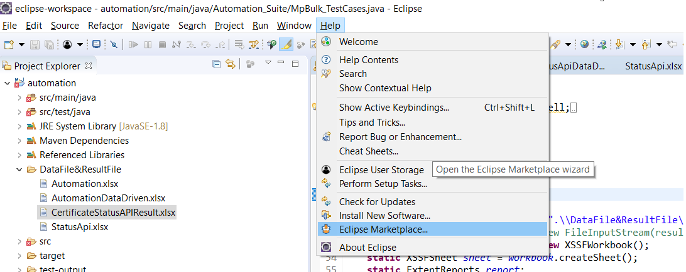
3. Click on ‘Eclipse Marketplace’. You will be directed to the marketplace modal. Type TestNG in the search keyword and hit ‘Go’. The referenced snapshot is below: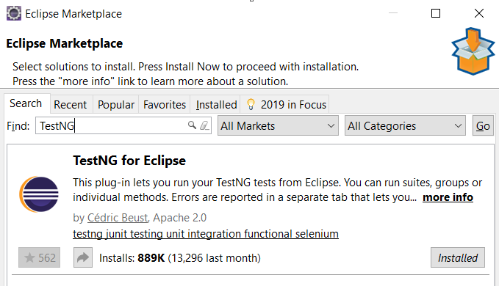
4. If TestNG is not installed in your Eclipse, rather than the ‘Installed’ button you would see ‘install’. Click on install and your TestNG framework will be installed in your Eclipse. As a good practice, Eclipse would recommend you to restart to use the features of the installed plugin
5. Post-restarting your Eclipse, re-verify whether you can see options for creating a TestNG class or not as below

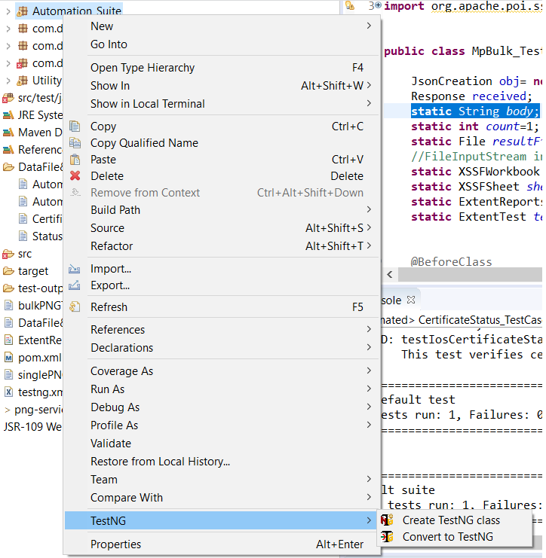

**TestNG Annotations**

An annotation tag provides information about the method, class, and suite. It helps to define the execution approach of your test cases and the different features associated with it. Below are the major annotations used:

* ***@Test***– This is the root of TestNG test cases. To use TestNG, all methods should be annotated with this annotation. Below is an example:

@Test

public void setupTestNG()

{

System.out.println(“this is a test annotation method”)

}

A few attributes associated with the TestNG annotation are:

1. **Description**: You can describe your test case under the description, stating what it does

@Test(description=”This test validates login functionality”)

1. **Priority**: You can [prioritize the order of your test methods in TestNG](https://www.browserstack.com/guide/prioritizing-tests-in-testng-with-selenium) by defining a priority. Based on the defined priority, the test shall execute in that order.

@Test(priority=1)

1. **DependsOnMethod**: This attribute works miracles if one test case is dependent on another. For example, to view your profile details, you need to login to the application. So, your profile test case is dependent on the login test case

@Test(dependsOnMethod=”Login”)

1. **Enabled**: Using this attribute, you can choose to execute or skip the execution of this test case. Setting it to true execute it and putting it to false will skip the test from the execution cycle

@Test(enabled=’true’)

1. **Groups**: Using this attribute, you can club your test cases into a single group and specify the group you wish to execute in your TestNG XML file. The test cases clubbed to that group will only be executed, and the rest will be skipped

@Test(groups=”Smoke Suite”)

While the above ones should help you get started, other major annotations are:

* **@BeforeMethod and @AfterMethod** – These annotations run before and after each test method
* **@BeforeClass and @AfterClass** – These annotations run once before and after the first*@test* method in a class
* **@BeforeTest and @AfterTest** – The BeforeTest annotation runs before the *@BeforeClass* annotation and the AfterTest annotation runs after the *@AfterClass* annotation
* **@BeforeSuite and @AfterSuite**– These annotations run before and after any test annotated method in a class respectively. These annotations start the beginning of a test and the end of it, for all the classes in a suite

Talking about the execution order of these annotations, they execute in the below order:

***@BeforeSuite -> @BeforeTest -> @BeforeClass -> @BeforeMethod -> @Test -> @AfterMethod -> @AfterClass -> @AfterCTest -> @AfterSuite***

**How to Write your First TestNG Test**

Using the above annotations and attributes, we will write our first test case with the TestNG framework. Let’s take the example of Browserstack, where we will open the landing page and sign up on the platform. Let’s write the code if you understand Selenium and its syntax fairly.

**Step #1 –** Create your first TestNG class by right-clicking on the package and selecting the’ Other’ folder from the ‘New’ option.  
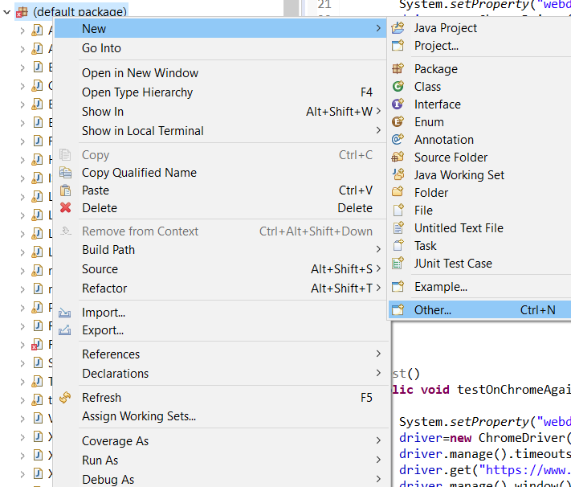

**Step #2 –**From the wizard modal, select the TestNG folder and select the TestNG class as below:  
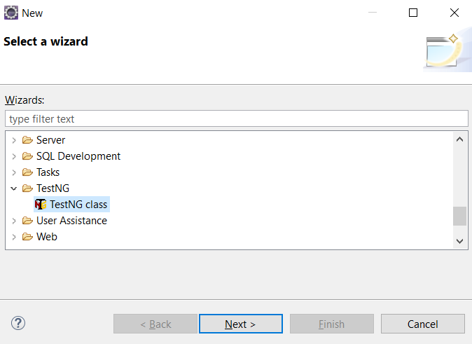

**Step #3 –**Click the ‘New’ button and choose any predefined annotations you wish to have in your class as below:  
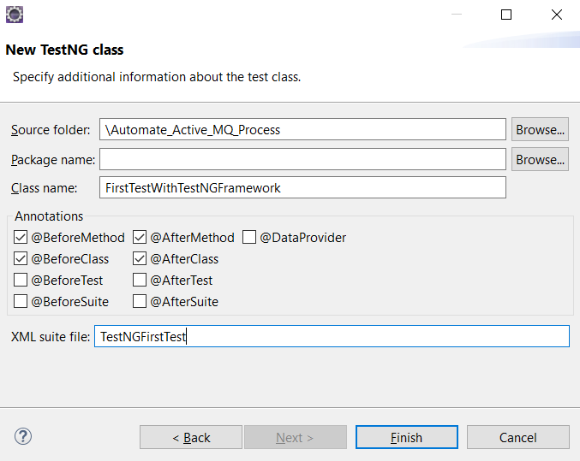

We will use *BeforeMethod, AfterMethod, BeforeClass,*and*AfterClass* along with our test annotation. Do note the XML file name is given on this modal. Using this TestNG XML file, we can choose to define our execution for the defined class or classes.

**Step #4 –**Click on finish, and you are ready to start writing your first TestNG class. Reference screenshot below, containing the defined methods with the annotations chosen in the step above: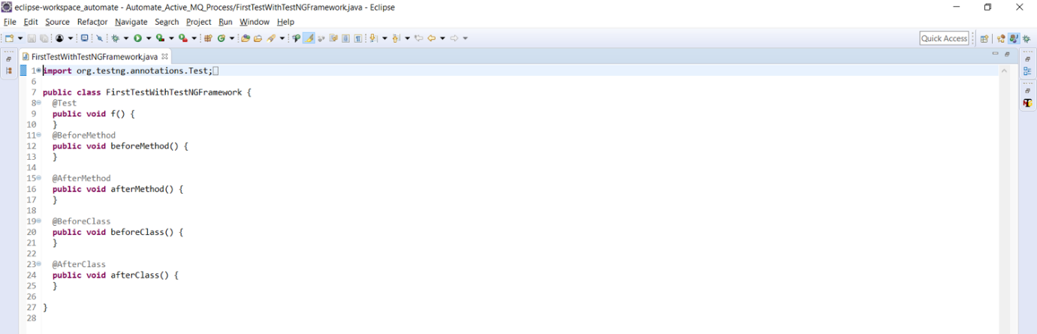

**Step #5 –**We will automate the sign-up flow using these annotations in the code snippet below.

import org.testng.annotations.Test;

import org.testng.annotations.BeforeMethod;

import org.testng.annotations.AfterMethod;

import org.testng.annotations.BeforeClass;

import java.util.concurrent.TimeUnit;

import org.openqa.selenium.By;

import org.openqa.selenium.WebDriver;

import org.openqa.selenium.chrome.ChromeDriver;

import org.testng.annotations.AfterClass;

public class FirstTestWithTestNGFramework {

WebDriver driver;

@BeforeClass

public void testSetup()

{

System.setProperty("webdriver.chrome.driver", ".\\Driver\\chromedriver.exe");

driver=new ChromeDriver();

driver.manage().timeouts().implicitlyWait(10, TimeUnit.SECONDS);

driver.manage().window().maximize();

}

@BeforeMethod

public void openBrowser()

{

driver.get("https://www.browserstack.com/");

driver.findElement(By.id("signupModalButton")).click();

System.out.println("We are currently on the following URL" +driver.getCurrentUrl());

}

@Test(description="This method validates the sign up functionality")

public void signUp()

{

driver.findElement(By.id("user\_full\_name")).sendKeys("user\_name");

driver.findElement(By.id("user\_email\_login")).sendKeys("email\_id");

driver.findElement(By.id("user\_password")).sendKeys("password");

driver.findElement(By.xpath("//input[@name='terms\_and\_conditions']")).click();

driver.findElement(By.id("user\_submit")).click();

}

@AfterMethod

public void postSignUp()

{

System.out.println(driver.getCurrentUrl());

}

@AfterClass

public void afterClass()

{

driver.quit();

}

}

As you can see, in this snippet above, we have used *@BeforeClass* annotation to setup the browser.

* In the *@BeforeMethod*, we have opened the [BrowserStack homepage](https://www.browserstack.com/" \o "BrowserStack" \t "_blank) and navigated to the [signup page](https://www.browserstack.com/users/sign_up).
* In the *@Test annotated* method, we are performing the sign-up functionality.
* In the *@AfterMethod*, we are printing the currentURL we are on
* And in the *@AfterClass* method, we are closing the browser.

Also, note the associated attribute ‘description’ used with the test annotation. Now, you must execute this test and validate your TestNG reports and console output.

**Step #6 –**To execute your report, you can either choose to run directly as a TestNG class or run the XML file created which contains the class name and details. Below is the auto-created TestNG XML file:

<?XML version="1.0" encoding="UTF-8"?>

<!DOCTYPE suite SYSTEM "https://testng.org/testng-1.0.dtd">

<suite name="Suite">

<test name="Test">

<classes>

<class name=".FirstTestWithTestNGFramework"/>

</classes>

</test> <!-- Test -->

</suite> <!-- Suite -->

You can modify the XML file and mention the various class names when executing multiple classes. You can also define the groups in the XML file you want to execute here. Once the modification is done, you can right-click on the file and run it. Your class containing the test shall be executed. Below is the referenced console output of the executed test: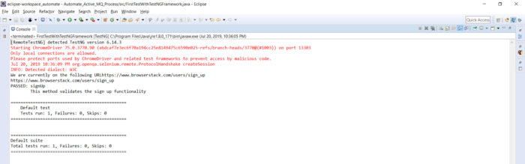

**Step #7 –**To access the TestNG report, you only need to refresh your project folder. A folder as ‘test output’ will be auto-generated. Within this folder, you shall see a file ‘index.html’ as below: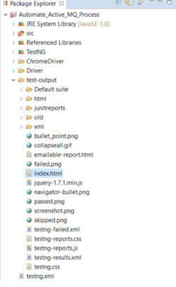

**Step #8 –**Double click on it and you can view your TestNG reports, showing the passed and failed methods of the execution as below.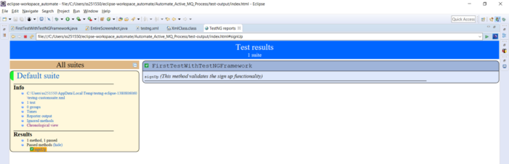

TestNG provides various listeners to customize this default report according to your needs. Learn more about [TestNG Listeners](https://www.browserstack.com/guide/testng-listeners). But this default report will be more than enough at the beginner level.

**Step #9 –**As a QA or tester, the next step is to validate your tests. If you did not validate your test methods, it basically means your testing process is incomplete. To validate your tests, TestNG provides assertions for it. So, let us investigate them to complete your TestNG tutorial.

TestNG Assertions

Like JUnit, TestNG provides multiple-level assertions to validate your actual results against your expected results. Few of the commonly used assertions are:

1. **assertTrue**– This assertion verifies whether the defined condition is true or not. If true, it will pass the test case. If not, it will fail the test case

Assert.assertTrue(condition);

1. **assertFalse**– This assertion verifies whether the defined condition is false or not. If false, it will pass the test case. If not, it will fail the test case

Assert.assertFalse(condition);

1. **assertEquals**– This assertion compares the expected value with the actual value. If both are the same, it passes the test case. If not, it fails the test case. You can compare strings, objects, integer values etc. using this assert

Assert.assertEquals(actual,expected);

1. **assertNotEquals**: This is just opposite to what assertEquals does. If actual matches the expected, the test case fails, else the test case passes

Assert.assertNotEquals(actual,expected,Message);

An important part to note in assertions is that your tests will not execute to the next line of code if your assertions failed. It will automatically jump to the next test annotated method.

Now, let us try to validate our code snippet below using assertions. In the snippet above, in the *@AfterClass* method, we will be verifying the current URL we are on and the expected URL, which should be the signup page.

@AfterMethod

public void postSignUp()

{

Assert.assertEquals(driver.getCurrentUrl(), "https://www.browserstack.com/users/sign\_up");

}

Make this change in your code snippet above and execute it. The test case should pass. Also try giving another expected URL, to validate if the tests fail.

### What is Parameterization in TestNG?

Parameterization is a powerful feature of TestNG that allows you to write more efficient and effective tests by reusing the same test logic with different input data.. It is useful when you need to test a particular functionality with different input values to ensure that it works correctly in all scenarios.

**Types of Parameterization in TestNG**

To make parameterization clearer, we will go through the parameterization options using the most popular testing framework, TestNG.

There are two ways by which we can achieve parameterization in TestNG:

1. With the assistance of the Parameter annotation and the TestNG XML file
2. With the help of the DataProvider annotation

* Parameters annotation with the Testng.xml file can be provided at the suite or the test level

Let’s study parameterization using TestNG and define parameters at suite and test levels in the Testng.xml file.

To do so, you need to:

* Create an XML file that will store the parameters. In the testng.xml file, we have two attributes for the parameter tag, the name attribute which defines the **name** of the parameter, and the **value** attribute defines the value of the parameter.
* In the test, add annotation @Parameters

I hope, by now it is clear how to create a TestNG class with no XML file; if not, then follow these basic steps: Right-click on your **package name** > **New**> **Other**> **TestNG**> **Next**> **Finish**

***Interested in learning TestNG? Check out the***[***Selenium training in Bangalore***](https://intellipaat.com/selenium-training-bangalore/)***!***

Now, to create an XML file, follow these steps:

**Step 1**:

1. Type the **Class name** as **checkTest2**
2. Type the**XML suite file** as **XML**
3. Click on **Finish**

**Step 2**: Add two-parameter tags with name and value attributes, each assigned with some values to them.

**Step 3**: Copy and paste the below code in your local system’s Eclipse IDE:

package VerifyTitle;

import org.testng.annotations.Parameters;

import org.testng.annotations.Test;

import org.openqa.selenium.WebDriver;

import org.openqa.selenium.chrome.ChromeDriver;

import org.openqa.selenium.firefox.FirefoxDriver;

import org.openqa.selenium.ie.InternetExplorerDriver;

public class checkTest2 {

WebDriver driver;

@Parameters({"browse","URL"})

@Test

public void launchBrowser(String browse,String URL) {

switch(browse) {

case "chrome":

System.setProperty("webdriver.chrome.driver","C:\\Users\\Intellipaat-Team\\Downloads\\driver\\chromedriver.exe");

driver = new ChromeDriver();

break;

case "firefox":

System.setProperty("webdriver.gecko.driver","C:\\Users\\Intellipaat-Team\\Downloads\\driver\\geckodriver.exe");

driver = new FirefoxDriver();

break;

case "IE":

System.setProperty("webdriver.ie.driver","C:\\Users\\Intellipaat-Team\\Downloads\\driver\\iexploredriver.exe");

driver = new InternetExplorerDriver();

break;

}

driver.get(URL);

System.out.println(URL);

}}

***Get familiar with the top***[***Selenium Interview Questions***](https://intellipaat.com/blog/interview-question/selenium-interview-questions/)***to get a head start in your career!***

**Step 4**: Run the code from the **parameterization.xml**file, and the **index.html** test report will look like the image shown below:

1. It opens the Chrome browser
2. It navigates to ‘<https://www.intellipaat.com/>’; the value provided is the one present in one of the parameter tags in the parameterization.xml file

In this TestNG in Selenium tutorial, so far, we learned about why TestNG came into existence, and the answer is that since the Selenium framework did not have its built-in testing framework, we require the help of some external testing framework that will help us generate test reports and simplify all our testing requirements such as functional testing, regression, end-to-end testing, and more. Then we learned what TestNG is all about and its advantages over JUnit. Also, we have seen how the installation of TestNG is done and how to write our first test case.

Later, we studied various TestNG annotations, viewed how to get the HTML test report, saw how to group multiple test cases, and understood what is parameterization. We can also integrate [Selenium IDE](https://intellipaat.com/blog/tutorial/selenium-tutorial/selenium-ide/) with various search engines to automate testing.